Notes from Climate Change Workshop 27th Feb at EA, Peterborough
Plus ideas on how to take the work of the impacts/risks/mitigation ideas? of Climate Change in the EoE on biodiversity
Catherine Weightman March 07
Participants were invited so there was good knowledge of biodiversity/organisations across the region.

Present at workshop
Matthew Chell -East of England Climate Change Partnership -facilitator
Catherine Weightman – Regional Biodiversity Coordinator
Hannah Webb – RSPB
Stuart Warrington – NT
Mark Iley – Essex WiT
Paul Wilkinson – Chair of the Regional Biodiversity Forum
Steve Scott – FC
Alan Wheeler – EERA
Julian Wright –EA
Marh Norden – Suffolk LBAP
Apologies
Richard Handley – EA
Sarah Hamley - NE

Background to the workshop
Richard Handley thought it would be a good idea if the Regional Biodiversity Forum organised a workshop based upon the
‘Risk and Uncertainty Decision-Making Framework’ – as developed by UKCIP
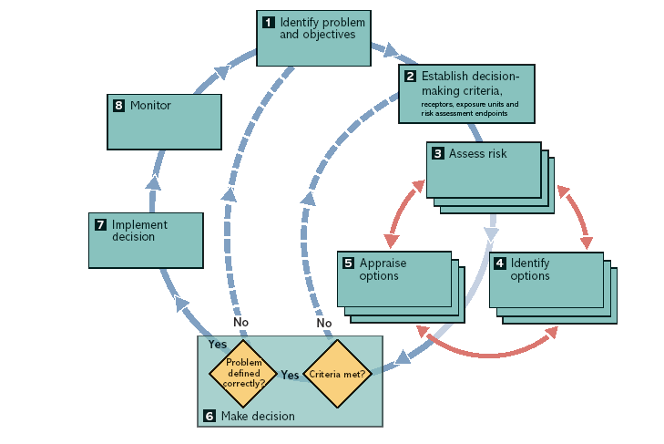
Structure of the day

Introduction to day
- Session 1: Identify objectives –SMART
Identified aims
Aim 1 Landscape scale approach
Aim 2 BAP objectives
Aim 3 Integrated Land Use
Aim 4 Engage economic/social sectors

Everyone agreed landscape scale approach was the way forward
To identify priorities habitats/areas, research eg Alde-Blyth, regional heathland project, lifescapes
Influence – policy and targeting eg RSS,LDF, LAA, HLF,Agi-env,EWGS, Carbon-tax,valuing ecosystem services, direct intervention – purchase of land
Regulation – planning directives, SEA, licensing
Centralisation of resources!
Stability, continuity of resources, reduce layers of management
Eg planning – flood plains, functional, no restricting development, appropriate land use-incl crops
Medium term – lobbying
On site management techniques, demonstrate successful adaptation
Eg grey water, composting, reed cutting, non native species, natural functioning wetlands, biofuels
Enhance biodiversity, value of all green spaces
Setback of flood defences
Connectivity of the landscape
Enforce the NERC act –all public bodies
Buy up land
Landscape scale strategies – NE, EA, NGOs
Scoping strategies to show what pattern this might take
Keep water on the land – create washlands – EA, RSPB, WT,landowners

- Session 2: Assess risks

Key threats were sea level rise, winter rainfall increase, summer water deficit

Coast /Marine
Sea level rise = coastal squeeze
Temperature of the water = marine life – losses and gains
Storminess/surges = saline destruction of habitats
Rainfall – less freshwater?
Wetland
Rainfall – summer draught
Temperature – increases in soil water deficit – fen soil blow
Sea level rise –brackish
Storminess – erosion/diffuse pollution to rivers
Loss of valley mires
Heathland
Temperature – increase invasive species?
Increased fires – not really a problem to heathland wildlife – but to humans
Overall it was thought heathlands in EoE would benefit from climate change
Woodland
Temperature and rainfall change in woodland character/penology
Arable
Greater demand for water
Soil structure
Changes of farming practices
Indirect –intensification demand for fuel crops/local food

Lunch

- Session 3: Identify options for action Categories of potential adaptations:

Do nothing option: No adjustment or alteration to plans
Win/Win and No/Low regrets options: Add some new adaptation options that lead to little or no additional cost and that will enhance regardless of climate change
High Resilience options: Make fully ‘climate proofed’. May be more costly
Avoid climate adaptation constraining decisions

- Session 4: Appraise options

Outcomes for the day

Group A Actions | Type | Smart | Aim 1 | Aim 2 | Aim 3 | Aim 4
1 Create x ha of wetland | w/w |  |  |  |  | 
2 Biodiversity in org strategies | w/w |  |  |  |  | 
3 Agri-env schemes –top action | w/w |  |  |  |  | 
4 enforce NERC | LR |  |  |  | 
5 land acquisition | HR |  |  |  |  | 
Group B Actions
1 Identify priority areas and habitats by 2010 – joint top | w/w  No/LR |  |  |  |  | 
2 Target grant schemes to meet above -ongoing | ? |  |  |  |  | 
3 More money for direct delivery by 2010 | HR |  |  |  |  | 
4 adoption of all PPS9 objectives in LDFs and RSS by completion of env standards | No/LR |  |  |  |  | 
5 Increase % of flood storage in each catchment by 20… - joint top action | w/w |  |  |  |  | 

Ideas for the next steps

1 Do nothing

2 Work with the EoE Climate Change Partnership to write the environment section of the Climate Change Implementation Plan for the EoE

3 Contact UKCIP/Dr Chris West (EoE region UKCIP contact) to get ideas how to progress this work.

4 Wait for Richard Handley to return from secondment in 5 months to get ideas how to progress this work.

5 Organise a Climate Change and Biodiversity conference in the autumn/winter. I think members of the Regional Biodiversity Forum would be keen to support this and I am sure I could find funding from somewhere to run such an event.
I have spoken to Mike Harley – NE lead on climate Change and he thought that this would be a good idea as the results of the NE pilot in the EoE on Climate Change would be available and Mike Harley thought that profile raising of the effects of climate change on biodiversity in the EoE still needs to be undertaken.

6 Production of a leaflet/map showing what large scale habitat recreation in the EoE is happening and /or we would like to see happening and how these recreation projects can help biodiversity mitigate/adapt to climate change.

7 Form a subgroup of the Regional Biodiversity Forum to progress this work and undertake the climate change element of the Implementation plan for the
Regional Biodiversity Forum.

8 Take the Networking Nature map forward to visioning map for the next RSS – for large landscape scale projects in the region – by working with the LRCs and county visioning maps.

9 Look at carbon sequestration/habitat management projects – it is probable that 60million pounds will come into the region – over 7years to be spent on low carbon projects – new technology, but perhaps somehow we could make the case for large scale habitat management projects to help to deliver a low carbon economy.

10 Hold Risk Ass workshops within the LBAP partnerships – similar to the one at a regional level.

